**BACHELOR’S DEGREE**

**COLLEGE OF INFORMATION TECHNOLOGY**

**AL-HUSSEIN BIN TALAL UNIVERSITY**

2023

Online clinic

Team Members:

-MOHAMMAD MOSTFA AWADALLAH

-HAITHAM HUSSAIN MUMAR

-ZAID AHMAD ALMASARWAH

-AYAH IBRAHIM MEGDADY

Supervisor: Dr. Mohammad Al-Jaafreh

**BACHELOR'S DEGREE**

**INFORMATION TECHNOLOGY**

AL-HUSSEIN BIN TALAL UNIVERSITY

2023

**(CERTIFICATION OF PROJECT)**

Permission to Use

In presenting this project in fulfilment of the requirements for a degree of  
Bachelor of Information Technology from Al-Hussein Bin Talal University, we agree that the University Library may make it freely available for inspection. We further agree that permission for the copying of this project in any manner, in whole or in part, for scholarly purpose may be granted by my supervisor(s) or, in their absence, by the College of Information Technology. It is understood that any copying or publication or use of this project or parts thereof for financial gain shall not be allowed without my written permission. It is also understood that due recognition shall be given to me and to Al-Hussein Bin Talal University for any scholarly use which may be made of any material from my project.

Requests for permission to copy or to make other use of materials in this project, in whole or in part, should be addressed to:

College of Information Technology

Al-Hussein Bin Talal University

Ma’an, Jordan

Abstract

Jordanian society is characterized as constructive, it is the duty of every Jordanian citizen to contribute to solving the problems that limit its development. Therefore, as programmers to fulfill their duty in developing and strengthening role in society as well as solving the problems that confront IT projects.

People around the world have changed ideas about prevention and sick visits.

We need all his visits to the doctor, and it should be easy and not cost much time or effort to visit the right doctor. This is what made us come up with the idea of the project, which is a website. We must help find the site Visit the site So, we worked on our website (online clink) Appropriate in terms of specialization and their opinion, opinion will provide many of the features discussed in this document.

Acknowledgement

First, praise be to Allah first and foremost for His immeasurable continuous giving Then we extend our sincere thanks to Dr. Muhammad Al-Jafarah For his enthusiasm, support, encouragement, and patience for the project.

Special thanks. Dear friends and family, and to our parents who set us on this path a long time ago.

Table of Contents

Permission to Use i

Abstract ii

Acknowledgement iii

Table of Contents iv

List of Figures 1

CHAPTER 1 Introduction 3

1.1 Project Background 3

1.2 Problem Statement 3

1.3 Project Objectives 3

1.4 Project Significance 4

1.5 Project Gantt Chart 5

CHAPTER 2 LITERATURE REVIEW 6

2.1 Scholarly Articles: 6

2.2 Existed Websites: 7

2.2.1 Booking online: 7

2.2.2 Skip the waiting room: 8

2.2.3 Doctor online: 8

2.2.4 Altibbi: 9

2.2.5 TEBCAN:(طبكان) 9

2.3 Online Clink is the best choice: 10

CHAPTER 3 Methodology 11

3.1 Construct Framework 11

3.1.1 incremental development 11

3.1.2 Pros for incremental development. 12

3.1.3 cons for incremental development. 12

3.2 Develop System Architecture 13

3.2.1 Pros Develop system architecture. 13

3.2.2 Cons Develop system architecture. 14

3.3 Analyze and Design the System 14

3.4 Build the Prototype System 14

3.5 Observe and Evaluate the System 14

CHAPTER 4 ANALYSIS AND DESIGN 15

4.1 Analysis 15

4.1.1 Requirements Determination 15

4.1.2 Software Requirements Specification (SRS) 16

Interview 16

User Requirements 16

System Requirements 17

Functional Requirements 17

Non-Functional Requirements 18

4.2 Design 20

4.2.1 Logical Design 20

4.2.1.1 Use Case Diagram 20

4.2.1.2 Sequence Diagrams 21

4.2.1.3 Entity Relationship Diagram 25

4.2.1.4 Database Schema: What's the Schema? It is the entire database organization conceptually as viewed by the database administrator.[17] 26

4.2.2 Physical Design 27

CHAPTER 5 findingS 29

5.1 Introduction 29

5.1.1 Front end 29

5.1.2 Back end 30

5.2 Project Interfaces and their Description 31

5.2.1 Home Page 31

5.2.2 Sign up Page. 35

5.2.3 Log in Page 36

5.2.4 Make Appointment 37

5.2.5 Doctor Profile 40

CHAPTER 6 OBSERVE AND EVALUATE 41

6.1 Introduction 41

6.2 System Screen and their Description 41

6.2.1 Log in page 41

6.2.2 Create Account 43

6.2.3 Make Appointment 45

6.3 Expected Error 46

6.4 Survey the result. 47

CHAPTER 7 CONCLUSION 49

7.1 Conclusion 49

7.2 Limitations 49

7.3 Future Works 50

references 52

List of Figures

Figure1. 1 Gant Chart 4

Figure3. 1 Incremental Model 12

Figure3. 2 Develop system architecture. 13

Figure4. 1 Use Case 21

Figure4. 2 Sequence diagram for Create Account 22

Figure4. 3 Sequence diagram for user login and logout 24

Figure4. 4 Sequence diagram for chose doctor and rate 25

Figure4. 5 Entity Relationship Diagram 26

Figure4. 6 Database Schema 27

Figure5. 1 components 31

Figure5. 2 Home Page 32

Figure5. 3 Home Page 33

Figure5. 4 Department Page 33

Figure5. 5 question page 34

Figure5. 6 Gallery Page 34

Figure5. 7 Contact Page 35

Figure5. 8 Create Account 36

Figure5. 9 Log in Page 36

Figure5. 10 Home Page 37

Figure5. 11 Search Doctor Page 37

Figure5. 12 List of Doctor Page 38

Figure5. 13 List of Doctor Page 38

Figure5. 14 Make Appointment Page 39

Figure5. 15 My Appointment Page 39

Figure5. 16 Log in for Doctor Page 40

Figure5. 17 List of Boking Page 40

Figure6. 1 Log in Page 41

Figure6. 2 Log in Page 42

Figure6. 3 Log in Page 43

Figure6. 4 Create Account Page 43

Figure6. 5 Create Account Page 44

Figure6. 6 Create Account Page 45

Figure6. 7 Make Appointment Page 45

Figure6. 8 Expected Error 46

Figure6. 9 Expected Error 47

# Introduction

## Project Background

A website is a group of interconnected, publicly accessible web pages that share a single domain name. Many fields depend on the presence of technology in their fields of work, and their presence Strong influence on the completion of these works with high accuracy and in a shorter time. Therefore, we have worked to create a web site to assist this generation, and it is used in Health, Scientific, Economic and Social fields.

In this project, we worked on developing a website in the health field that displays the names and locations of doctors in private clinics, specialties, and the extent of their experience in all regions of Jordan Kingdom.

## Problem Statement

Our current era is facing many problems in terms of finding the suitable doctor with high confidence and the nearest location. And we found that many people face problems in booking appointments with appropriate doctors, and waiting for a long time in clinics, and the lack of communication between the patient and the medical staff (doctor, nurse, laboratory technician, etc.) as well as knowing the doctor’s experience and ranking as well as expressing opinion to the public.

## Project Objectives

Our goal as a team is to work on developing a website that achieves these goals:

1-To make it easier for patients to book appointments at clinics.

2-To Know the doctors’ experiences and their locations.

3-To help patients to choose the right doctor and the closest to their location.

4-To allow patients to evaluate the doctor after the review.

5-To organize time for patients and clinics by using filters.

6-To display appointments on servers and Doctor's specialty.

## Project Significance

And because we are in the age of technology and speed, this site saves a lot of time and effort for the patient. It is imperative that we have a website like this one and we have a lot of positive points like:

1-Online Clinic can save patients time in booking appointments, and available appointments in the clinic can be booked at any time convenient for the patient.

2-Booking appointments with clinics is not limited to working hours, but at any time, and this means that patients can book appointments at their leisure; Not while they are working, busy, but any time convenient for them.

3-Patients who live in areas where there are no specialized doctors, they can search for the nearest clinic to them and book without the need to travel to the clinic site.

## Project Gantt Chart

Gantt chart tracks project schedules, shows information for specific tasks, visualizes them, and shows how project organizes over planned time. It includes task name (the first column) and runs along the right side; the time scale for each activity. Each activity is represented by a bar, and the position and length of the bar express the start date, duration, and end date.

The project's Gantt chart appears in Figure 1.1

Figure1. 1 Gant Chart

# LITERATURE REVIEW

Health care management is a very important issue, Literature review section presents a comprehensive summary of previous research, scholarly articles, books, web sites and other sources relevant to management of health care.

The review enumerates, describes, summarizes, objectively evaluates, and clarifies previous sources. It gives a theoretical base for the research and helps us determine the nature of research.  Besides, the literature review acknowledges the work of previous researchers and assures the teamwork has been well conceived by mentioning previous work Health care management of study and assimilating that work.

## Scholarly Articles:

Firstly, Eide et al. expressed the idea of the health needs for individuals; the individual’s health is at the heart of the defense of human rights. It includes the right to survive and to live without inevitable suffering. The Universal Declaration of Human Rights recognizes the right to health, stating that:

“Everyone has the right to a standard of living sufficient to ensure the health and well-being of himself and his family, especially in terms of food, clothing, housing and medical care…”

This definition was based on the existing view of Human Rights in the eighteenth and nineteenth centuries, The Government must take measures to ensure that all citizens enjoy an adequate standard of living, with regard to food, clothing, housing, medical care, and necessary social services As essential elements of an adequate standard of living in terms of health and well-being and should not prevent individuals from enjoying their civil and economic rights.

Eide et al. 386 Article 25 of the Universal Declaration of Human Rights also includes a statement that [Bloomsbury university -- University of Minnesota human rights office].[1]

## Existed Websites:

Secondly, many existed websites have tried to solve this problem by booking appointments and showing the evaluation of the clinic, these applications are listed

below:

2.2.1 Booking online:                                 
A Greek application based on providing the booking process for treatment and the help that patient need**.** [2]

|  |  |
| --- | --- |
| Online clinic | Booking online |
| Ease and convenience of registration and creation of accounts within the site and convenient arrangement for the visitor | Difficult to create accounts within the site |

2.2.2 Skip the waiting room:                      

A Canadian site that relies on providing the help for doctors to run their clinics and bring their information online.[3]

|  |  |
| --- | --- |
| Online clinic | Walk in clinic |
| There is an evaluation of doctors, and there is appropriate feedback to be a reference that patients can rely on to know the evaluation for doctors, The patient can decide right doctor. | There is no evaluation of doctors, and there is no appropriate feedback to be a reference that patients can rely on to know the evaluation for doctors, The patient cannot decide right doctor. |

2.2.3 Doctor online:                                       

An Egyptian site that relies on providing booking process and facilitating communication between the patient and the doctor, in addition to exploring clinic near you on the map. [4]

|  |  |
| --- | --- |
| Online clinic | Doctor online |
| We created the site to meet the needs of patients and reviewers in Jordan | There are no clinics inside Jordan that meet the patient's needs |

2.2.4 Altibbi:**(**الطبي) 

https://www.crunchbase.com/organization/altibbi

It is an application for communication between the doctors and the patient. [5]

|  |  |
| --- | --- |
| Online clinic | Altibbi: (الطبي) |
| A free registration site for clinics with the best features and ease of use | A commercial site, you must **pay** to make reservations and inquiries, contact the doctors |

2.2.5 TEBCAN:(طبكان)                            

An application to improve the health of patients by providing access to appropriate healthcare.[6]

|  |  |
| --- | --- |
| Online clinic | Tebcan:(طبكان) |
| The online clinic application contains all regions within the country, which is the main point of the application, to make it easier for all patients inside the country to find the clinic near them. | This application does not include all regions within the country, but it is concerned with areas with a high population density. |

## Online Clink is the best choice:

The right doctor can be chosen through Online Link. We also added the site feature to our website, so that the patient can choose the right doctor and the closest, and you can book an appointment with the right doctor at any time. You can know the doctor’s experience and you can evaluate your doctor after the treatment period. The Online Clinic website provides patients with everything they need to book with the right doctor.

# Methodology

Online clinic projects have specific goals that must be achieved by following a certain methodology, and in this chapter, the importance of applying the appropriate methodology for project management and achieving the desired goals.

After studying different methodologies and choosing the best for our project. The outline, pros and cons of chose methodology as well as its description and suitability for our project will presented.

## Construct Framework

According to online clinic project environment which is similar to an agile environment; so, the incremental development methodology is very suitable to achieve project goals.

### incremental development

Incremental Model is a process of software development where requirements are divided into multiple standalone modules of the software development cycle. In this model, each module goes through the requirements, design, implementation, and testing phases. Every subsequent release of the module adds function to the previous release. The process continues until the complete system is achieved.[7]

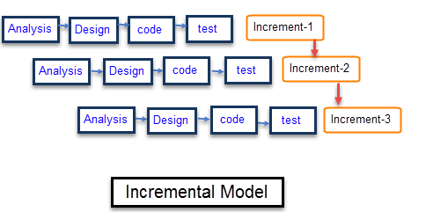

Figure3. 1 **Incremental Model**

### Pros for incremental development.

-This model is less costly compared to other

-A customer can respond to each building

-Errors are easy to be identified

-The software will be generated quickly during the software life cycle

-It is flexible and less expensive to change requirements and scope

-Throughout the development stages changes can be done

### cons for incremental development.

-Rectifying a problem in one unit requires correction in all the units and consumes a lot of time

-Each iteration phase is rigid and does not overlap each other

-Problems might cause due to system architecture as such not all requirements collected up front for the entire software lifecycle.

Fortunately, the advantages are obvious More than the shortcomings of our project.

## Develop System Architecture

After studying different architecture and choosing the best for our project. The outline, pros, and cons of chose architecture as well as its description and suitability for our project will presented.

The principal advantage of this model is that servers can be distributed across a network. General functionality (e.g., a booking service) can be available to all clients and does not need to be implemented by all services. ​

Figure3. 2 Develop system architecture.

### Pros Develop system architecture.

Easy to understand and supports transformation reuse. Workflow style matches the structure of many business processes. Evolution by adding transformations is straightforward. Can be implemented as either a sequential or concurrent system.​

### Cons Develop system architecture.

The format for data transfer has to be agreed upon between communicating transformations. Each transformation must parse its input and unparsed its output to the agreed form. This increases system overhead and may mean that it is impossible to reuse functional transformations that use incompatible data structures.​

## Analyze and Design the System

In our project, the analysis and design that phase used the Unified Modeling Language (UML) in several stages.

By using an official app like (diagram, dB designer, visual paradigm). UML has several representations.

Like class diagram, use cases diagram, sequence diagram, data flow diagram.

## Build the Prototype System

In fourth phase is prototype implementation to demonstrate the functionality of Online Clinic project, the development processes involved transforming the analysis and design the model into executable form, PHP language is used to write project’s software; the detailed of Online Clinic.

## Observe and Evaluate the System

The researchers will evaluate Online Clinic project by observing performance of the system and test its functionality as the final phase in system development; this will be discussed in chapter 6.

.

# ANALYSIS AND DESIGN

## Analysis

It is the first phase of SDLC that involves gathering system requirements. At this stage, Business needs are studied to make business operations more efficient. Accurately defines system planning activities. All system needs will be understood. All relevant information from the client for product development without any ambiguity. system analysis stage Focuses on what the system will do to have all stakeholders informed as viable sources.

### Requirements Determination

Defining requirements is the beginning of the sub-stage of the analysis. One of the most important stages that the analyst performs is defining Business requirements and must gather information about what the system should do, since requirements are what the system can do and the specifications that the system must have from the largest number of sources.[8]and the system analyst must follow some of them Practical requirements gathering techniques such as questionnaires and interviews and ban users directly. The requirements reached must undergo a careful analysis process to get rid of duplicate requirements and competition from business requirements set forth in the system request in a more accurate list of requirements They can be used as input for the rest of the analysis phase (creation of use cases, build process models and data construction) and may require it Review requirements and renegotiate with clients. This should be the most important point in project documentation and the beginning because the project (specification) in it is clear and (unambiguous) ID. Project requirements are a complete description of the functions and System properties.[9]

### Software Requirements Specification (SRS)

A software requirements specification is a detailed description of the software system to be developed with its functional and non-functional requirements. SRS is developed Based on the agreement between clients and contractors. Use cases may include How the user interacts with the software system. Program requirements the specification document consists of all the requirements required for project development. to me Software system development, we must have a clear understanding of the software system. To achieve this, we need to continue to communicate with customers to bring everyone together requirements.[10]

### Interview

We conducted several interviews with doctors in Aqaba and Ma’an, due to the lack of doctors and irregular appointments with patients, and through this interview the doctor’s answers focused on the problems they faced in booking appointments in their clinics.

Online Clinic Site will present a solution for their problems:

* Helps them organize appointments.
* has an evaluation of the level of excellence and organization they have.

Their answers are recorded and elicited in User Requirement section.

### User Requirements

This site will allow the user to log in or create a new account if the account is

not registered in the application then

Choose the doctor’s specialization, region, and if there are any other preferences, such as the doctor’s gender.

Then the site will show the closest appointments after choosing the appropriate doctor

### System Requirements

Software system requirements are often classified as functional or non-functional.

What is a non-functional condition?

A non-functional requirement is an attribute that defines how a system works. It makes applications or programs run more efficiently and shows the quality of the system. Non-functional requirements differ from functional requirements in the following ways:

1.Mandatory vs. Non-mandatory: Unlike functional requirements, non-functional features are not mandatory for the operation of the system. Instead, these features can help set an app apart from other products on the market.

2.Basic operations vs. additional features: Functional requirements encompass what a system does, while nonfunctional requirements cover how a system completes a task. For example, the functional duty of a camera is to take pictures. The nonfunctional duty is to take pictures with enhanced focus and clarity.

3.Intended purpose vs. customer expectations: While functional requirements focus on the purpose of an application, nonfunctional requirements center on the users' expectations, such as the product's performance.

### Functional Requirements

Functional requirements focus on how the software must perform and specify the

desired behavior of the system. [11]

**Create an account (Sign up\Login)**

• The user can sign up by entering the required information.

• The user can log in to his account if he is already having one.

• The user can access his personal data that he entered when creating his account.

• The user can edit his personal data.

### Non-Functional Requirements

Non-Functional requirements are critical to the usability of a software system, and if

you do not define them carefully; the end users’ experience can be adversely affected. [12]

**Speed**

Speed ​​determines how quickly a site can respond to commands. For example, if you type a word into a search engine, the speed of the engine determines how quickly you receive search results.[12]

**Security**

To protect sensitive data, you may consider developing non-functional security features. For example, professionals in healthcare facilities use secure databases to store patients' medical records. Security in their databases may include firewalls to prevent unauthorized access.

Account creation: Systems may require users to create accounts to access applications that store information and display profiles. A security system typically grants access to accounts when users enter the correct username and password.

Password generation: An application may not grant access until the user creates a strong password. For example, a strong password might contain a certain number of characters and a capital letter.

Security question answering: A security system for a product may ask questions that only the user knows the answer to. This can help verify a user's identity when they log into an account. Examples of security question topics include the color of your first car or your mother's family name.

Account locking: After a certain number of login attempts, a security system may lock an account to protect a user's information from potential hackers. To unlock their account, a user can typically call the company to verify their identity and set a new password.[13]

**Location**

The translated app has features that are compatible with the geographic location of its users, including aspects such as:

**Usability**

The user can use the site easily without training and

The app has a navigation bar which includes some frequently used features

Increase the speed of access, most often any button or field on the site contains text

And code at the same time, for easy understanding of the button function

or field, and the site provides some features for which you do not need to log in.

the use usability refers to the ability to use a particular product, including elements such as:

Navigation: When an application is usable, users can easily navigate its interface. For example, if a person navigates an effective user interface (UI) for a streaming service, they can understand how the application organizes its content and know where to access pages such as settings.

Purpose of features: With high usability, users can easily determine what a feature is and what it can do. For instance, they might predict that tapping a button with a picture of a magnifying glass may open a search bar.

Quality of performance: When a device performs well, it means that the features of a system are functioning well based on what a developer predicted. For example, if an application label states it can improve a cell phone's battery life, the user may assess battery life over time to determine whether the product performed as expected.

**Performance**: The application has a high responsiveness under different workloads.

## Design

The purpose of the design is to transform the requirements into complete and detailed.

system design specifications. Once the design is approved, the development team begins.

the development phase.

### Logical Design

A logical design is a conceptual, abstract design. You do not deal with the physical

implementation details yet; you deal only with defining the types of information that you need. [14]

#### Use Case Diagram

It is an illustrative general design to determine actor interact with the system and the case and procedures of the system and are described in the order. [15]

use case scenario:Patients can view the site without login. Patients can login to the site if they have an account. In the absence of an account, customers register on the site

with their personal information. after entering, Users can choose a doctor, book an appointment with him, and then rate him afterwards Can be logged out.

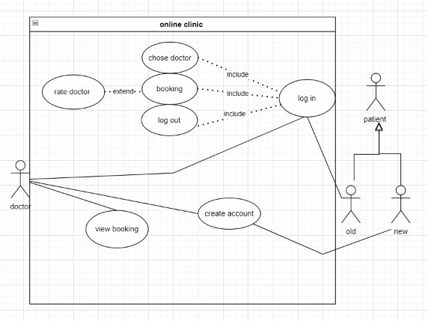

Figure4. 1 Use Case

#### Sequence Diagrams

**1. Sequence diagram for Create account use case**

|  |  |  |  |
| --- | --- | --- | --- |
| Use case | Description | Actor | Data |
| create account | Create a new account, the patient enters the desired  Data, the data is sent to the database to check whether the calculation is correct or notNo, if they exist, say, a message is sent to the patient with  Error and show him, otherwise the data is stored, the account isOnce created, the site directs the user to the home screen | Patient | Patient information |

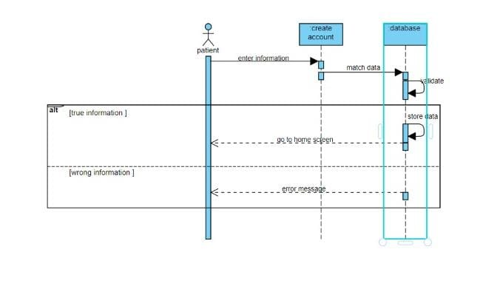

Figure4. 2 Sequence diagram for Create Account

**2. Sequence diagram for user login and logout use cases**

|  |  |  |  |
| --- | --- | --- | --- |
| Use case | Description | Actor | Data |
| Log in  log out | The patient enters the email and password. The data is sent to the database if it is correct, the user is logged in, and The site directs the patient to the home screen, otherwise the message will be.  It is sent to the patient with the error, and it is shown to him, and the patient can enter. And it takes him back to the login screen | Patient | Email  Password |

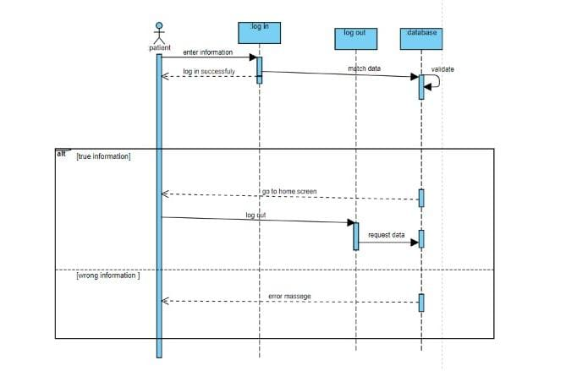

Figure4. 3 Sequence diagram for user login and logout

**3. Sequence diagram for chose doctor and rate**

|  |  |  |  |
| --- | --- | --- | --- |
| Use case | Description | Actor | Data |
| Chose  rate | The patient logs in, and then can submit a doctor's choice in addition to; Choose by location, then he can rate the doctor and show the rate on the site | Patient | Patient information |

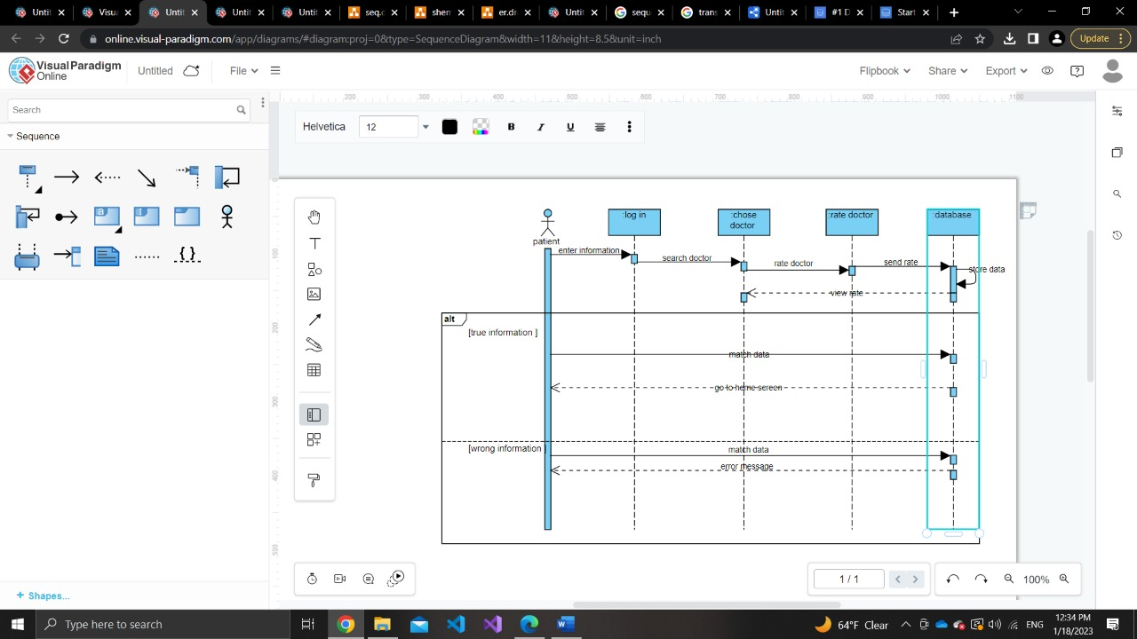

Figure4. 4 Sequence diagram for chose doctor and rate

#### Entity Relationship Diagram

It is a data modeling tool that uses a high-level conceptual design to achieve the goal of describing data or depicting it in an abstract way and describing the relationship of entities with each other and also helps reduce errors and redundancy in the database. Among the main concepts in this model are entity, attribute and relationship.[16]

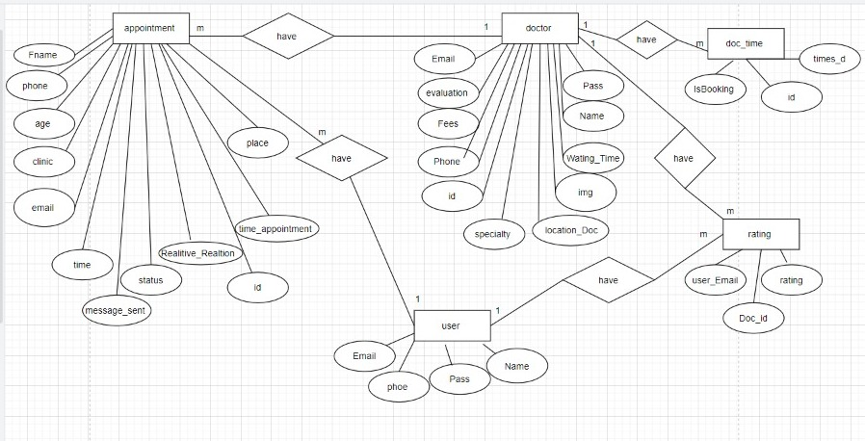

Figure4. 5 Entity Relationship Diagram

#### Database Schema: What's the Schema? It is the entire database organization conceptually as viewed by the database administrator.[17]

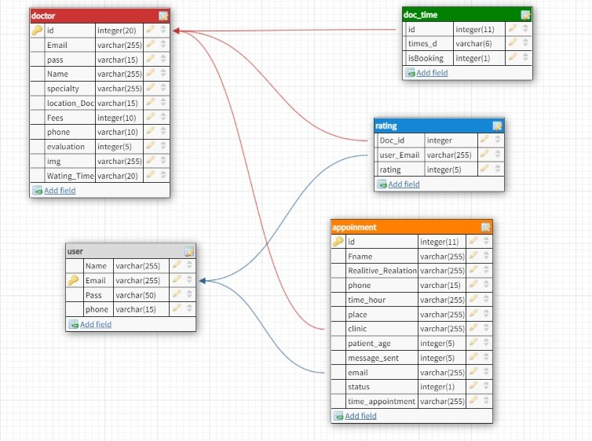

Figure4. 6 Database Schema

### Physical Design

Meanwhile, physical design deals with the process of converting the logical design into a more technical specification of the system development. In designing the physical part of the system, all diagrams that were produced in the logical design were turned into a structured systems design. During physical design, the researcher determined which programming language and database system will be used as well as the determination of which hardware platform, operating system, and network environment the system will run under. The specifications are portrayed in table 4.1.

|  |  |
| --- | --- |
| Purpose | H/W. S/W Requirement |
| Front-end  Back-end  Operating System | HTML, CSS, JS, Bootstrap, AJAX  PHP, MySQL  n Online Clinic project we used two windows 11 laptops, one window 10 laptop and one window 10 personal computer (PC) |
| Hardware | the pc hardware is corei5 10generation, NVidia RTX2070,16ram.One of the laptops is corei5 8generation,NVidia MX110,4ram.The other laptop is corei7 8generation,NVidia MX110, 8ram.And the last laptop is Rwzen5,NVidia GTX1650ti,8ram. |

# findingS

## Introduction

In Online Clinic set of tools are used and software to complete our project in addition to a programming language and framework, and these tools are mentioned as follows:

### Front end

The design of the interfaces and the external structure in the system and the

instructions related to it by using HTML, CSS, and JS.

**HTML**

Hyper Text Markup Language (HTML) is a markup language used in creating and

Synthesizing web pages and websites, and this language is one of the widely used and oldest.

languages in Synthesizing web pages with CSS. HTML and JS form the structure of the web page and  gives the internet browser a description of how to display its contents.

HTML uses what are known as tags to issue instructions to the browser. These tags are placed between greater than “>” and less than “<.”

HTML used many of text editors such as VISUAL STUDIO, also when storing a file.

HTML, its extension is as follows Filename.HTML.

**Cascading Style Sheet (CSS)**

The method we use to give the general appearance of

web pages (sequence, colors, backgrounds, font sizes, type, etc.).

While HTML is concerned with the structure of the page and its description of its

elements, CSS is considered complementary to it as it coordinates and decorates.

What has been accomplished in the HTML file.

**Java script (JS)**

A programing language of the web pages and its open source, we use JS.

to program the behavior of web pages, it is included in modern browsers and

can be used easily when loading a web page.

**Bootstrap**

Is a free and open-source CSS framework for front-end web development that is focused on responsive, mobile-first design. It includes design templates for typography, forms, buttons, navigation, and other interface components in HTML, CSS, and (optionally) JavaScript.

**Asynchronous JavaScript and XML (AJAX)**

In short, AJAX is about loading data in the background and displaying it on the webpage, without reloading the whole page (jQuery AJAX Introduction).[18]

### Back end

 The database of online clinic is connected to web pages by using PHP and MySQL.

PHP (Hypertext Preprocessor):

PHP is Server-Side Scripting Language, it developed to be open source and

Widespread, and links databases with Front end.[19]

Database compatibility: PHP works with MySQL.

OS compatibility: can work on any operating system.

PHP files have extension ".php".

## Project Interfaces and their Description

### Home Page

It appears for anyone who visits the site without needing to registration into the site and it shows many components as shown in figure. 5.1

Figure5. 1 components

|  |  |
| --- | --- |
| The logo | Description |
|  | The logo of online clinic |
|  | Increases turnout with automated appointment reminders |
|  | Ensures better allocation of resources |
|  | Account name |
|  | Save time |
|  | Frequently asked question |
|  | Connect |
|  | Social media |
|  | Button to back up |



Figure5. 2 Home Page

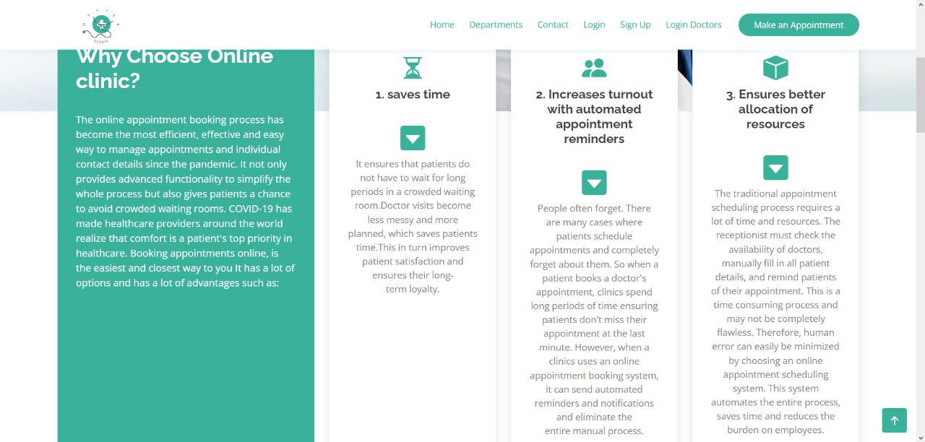

Figure5. 3 Home Page

**Department page**

It appears for patient who register in the site, and it shows the available departments shown in figure.

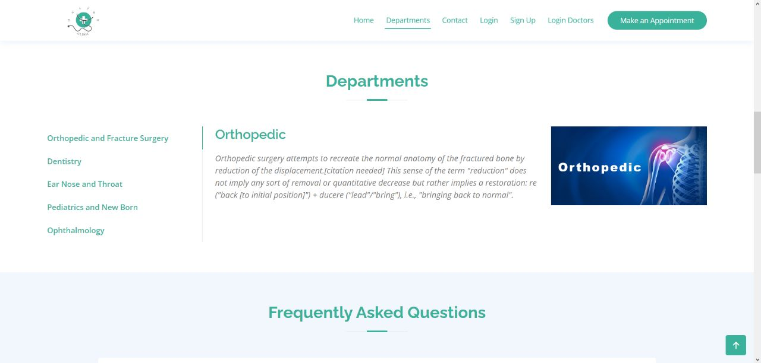

Figure5. 4 Department Page

**question page**

This page shows the most frequently asked questions and answers to these questions.

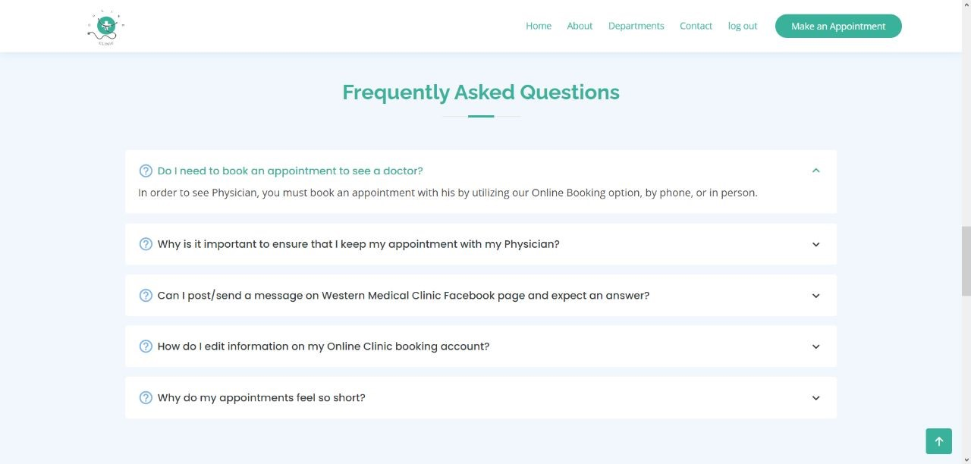

**Figure5. 5 question page**

**Gallery Page**

Some pictures of the clinics included in our Online Clinics.



Figure5. 6 Gallery Page

**Contact Page**

It appears for patient who register in the site, and it shows the available clinics’ locations as shown in figure. 5.7

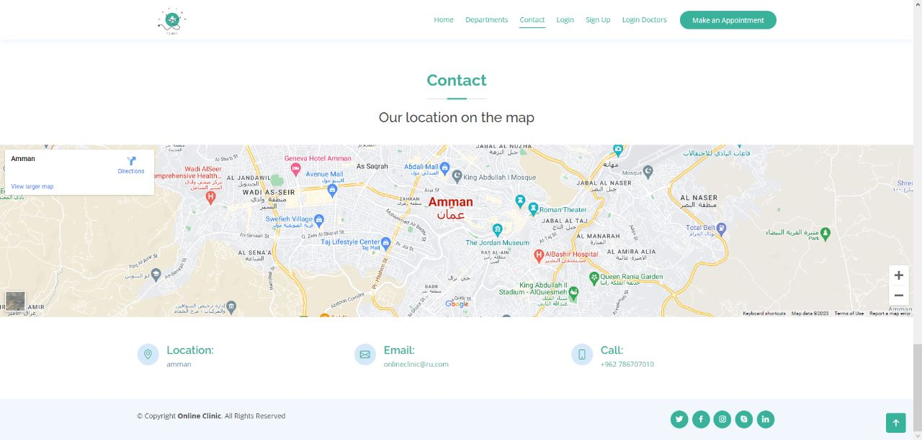

Figure5. 7 Contact Page

### Sign up Page.

This screen shows: full name, email, password, and mobile phone number” input boxes and order the site to send a passcode to patient for verifying his registration.

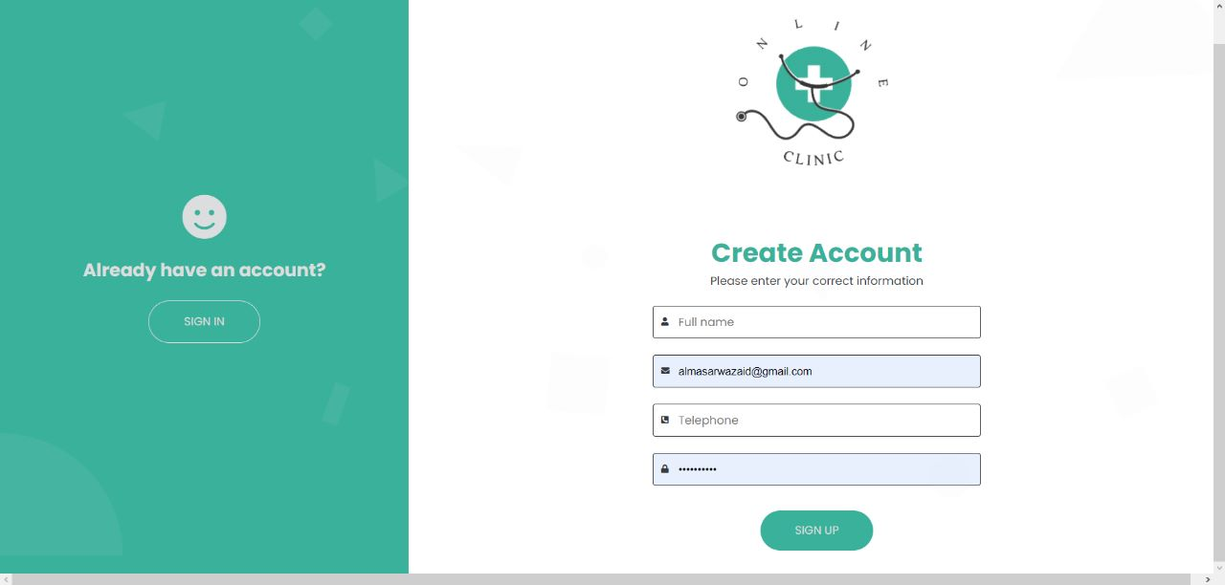

Figure5. 8 Create Account

### Log in Page

This screen shows email and Password fields and login button.

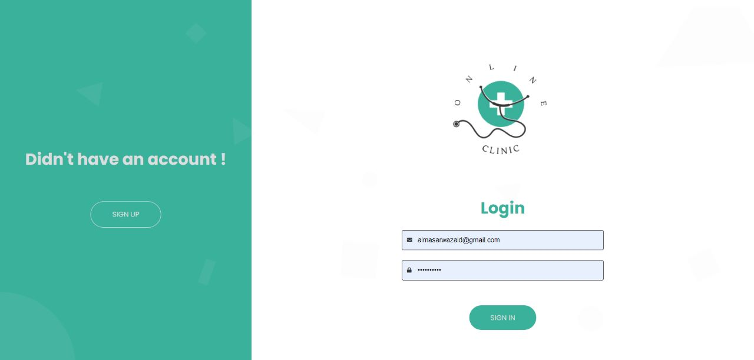

Figure5. 9 Log in Page

This home page appears after logging in.

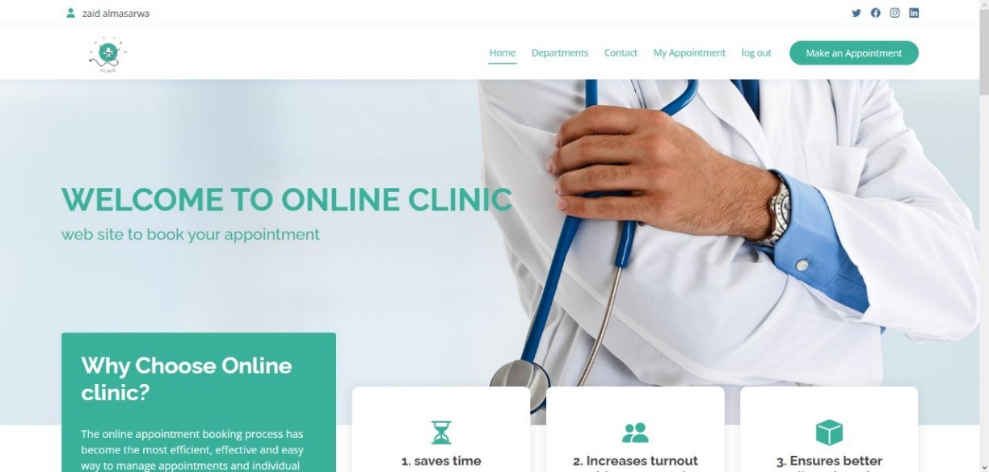

Figure5. 10 Home Page

### Make Appointment

This home page appears after logging in when the patient wants to search for the doctor's location and specialty.

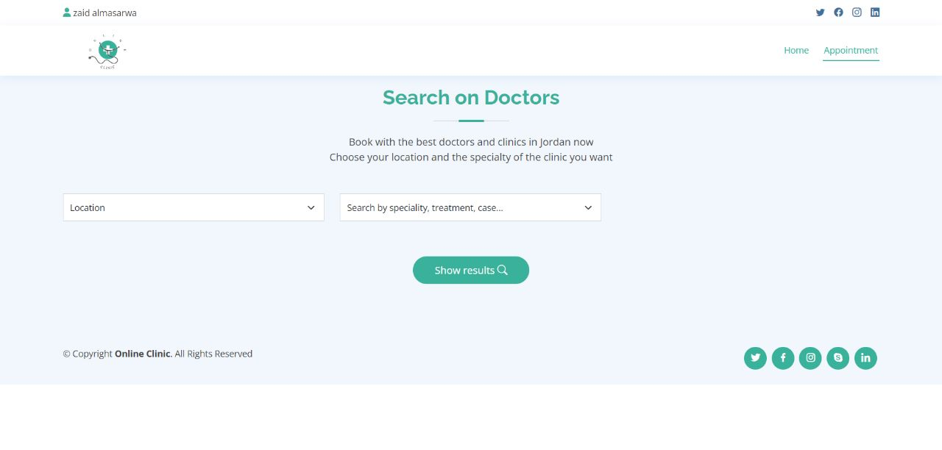

Figure5. 11 Search Doctor Page

This page shows the doctor's information and rating.

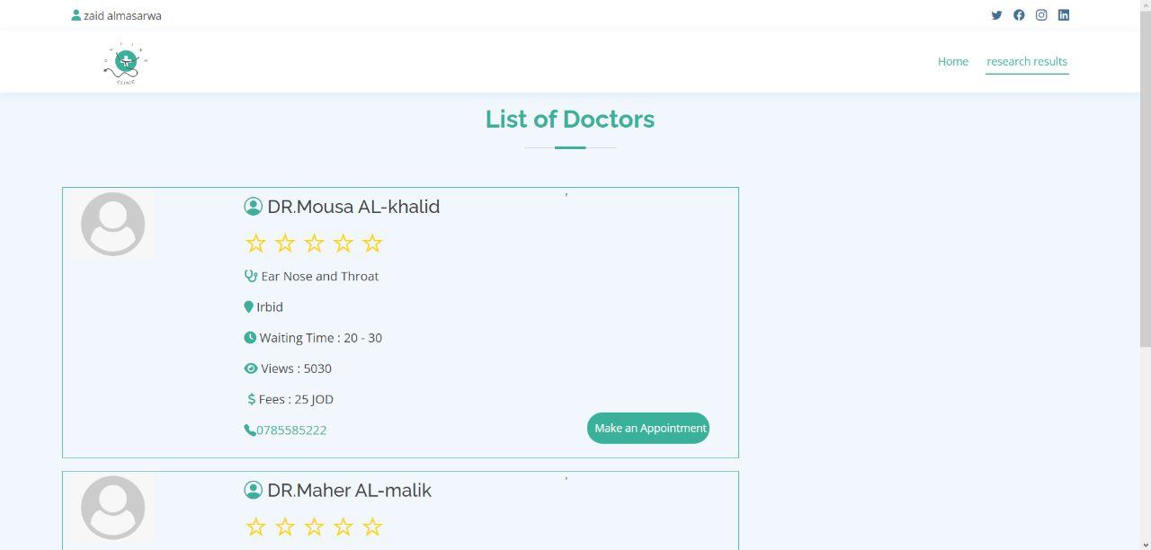

Figure5. 12 List of Doctor Page

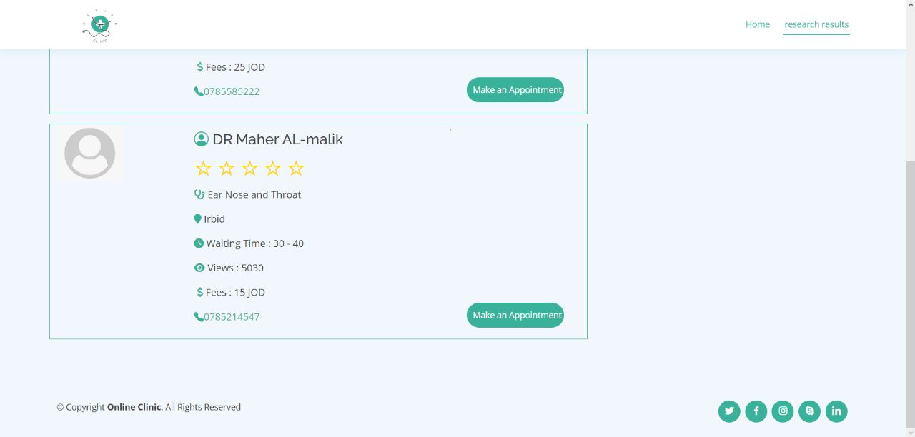

Figure5. 13 List of Doctor Page

This page shows some options to facilitate the search for clinics close to patient as shown in figure.5.14

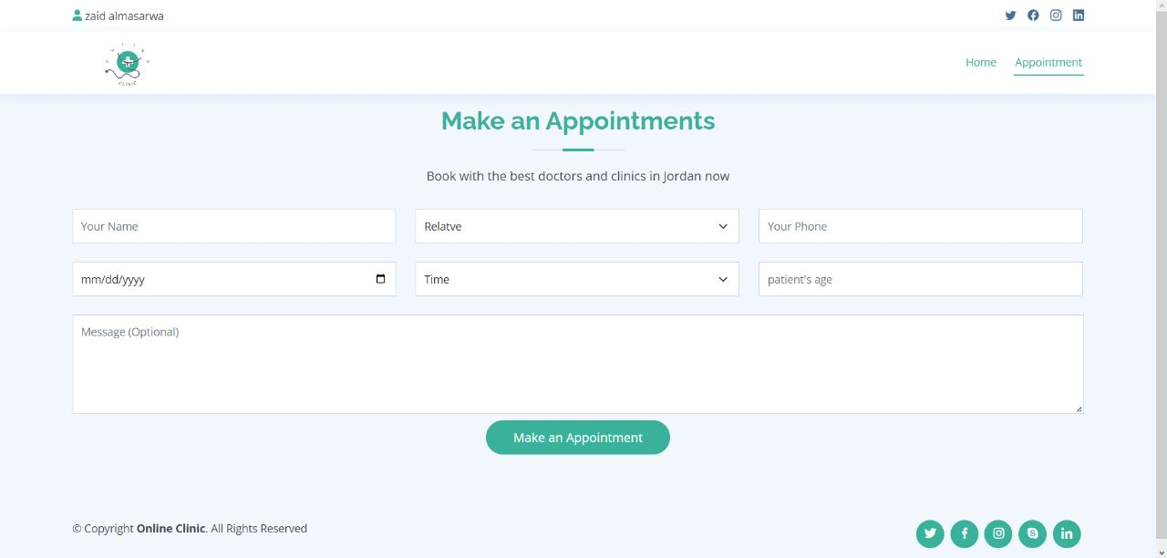

Figure5. 14 Make Appointment Page

This page shows the patient his appointments.

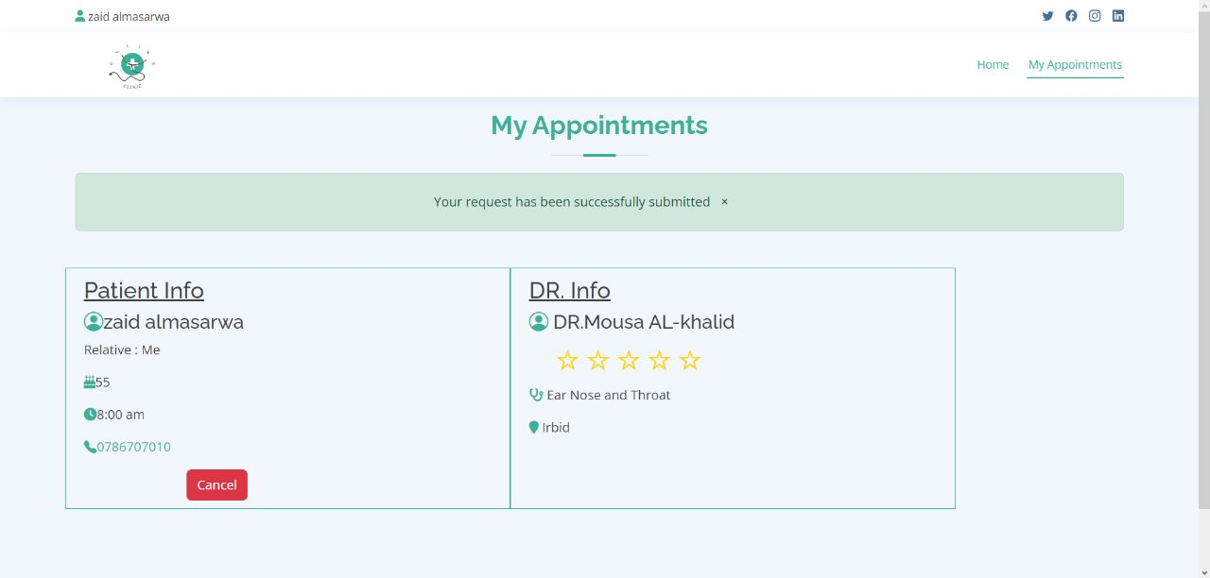

Figure5. 15 My Appointment Page

### Doctor Profile

This screen shows email and Password fields and login button for doctor.

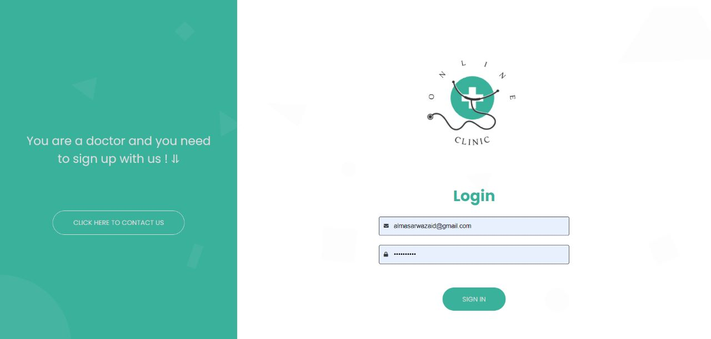

Figure5. 16 Log in for Doctor Page

This page shows the appointments booked by the doctor.

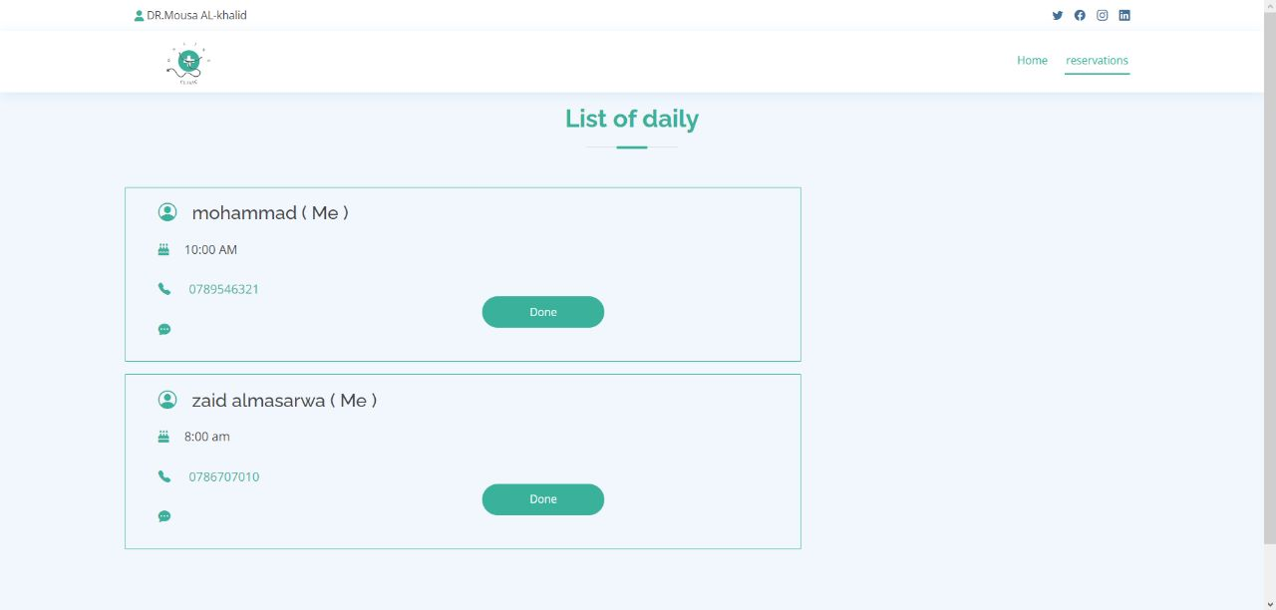

Figure5. 17 List of Boking Page

# OBSERVE AND EVALUATE

## Introduction

In this chapter we will talk about the testing process that was used. The importance of this stage lies in the fact that it is the basis for the Development and Testing stage. Through it we can locate and know the fault locations within the system and check if the system is working properly and can achieve the goals for which it was created.

## System Screen and their Description

### Log in page

In the event that you click on the (sign) button, and the fields are empty, a message will appear for you above the email field (please enter your information) when all fields are filled correctly, the account will be created successfully.

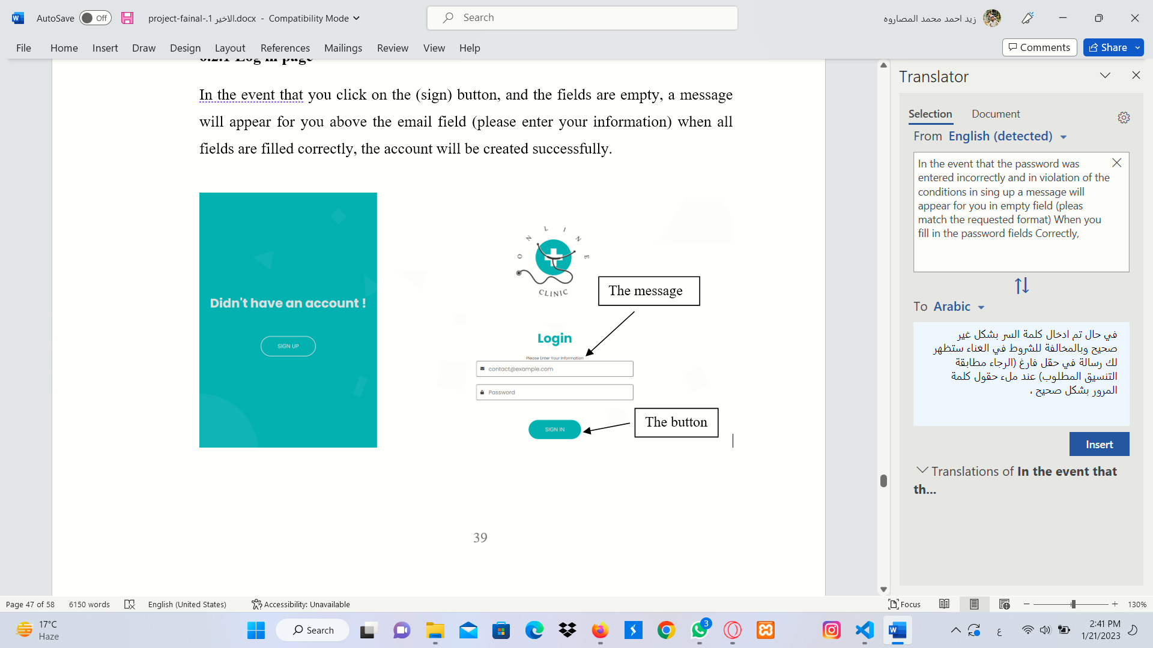

Figure6. 1 Log in Page

In the event that you click on the sign and the password fields are empty a message will appear for you above the email field (please enter your password) When you fill in the password fields Correctly, the account will be created successfully.

Figure6. 2 Log in Page

In the event that the password was entered incorrectly and in violation of the conditions in sing up a message will appear for you in empty field (pleas match the requested format) When you fill in the password fields Correctly,

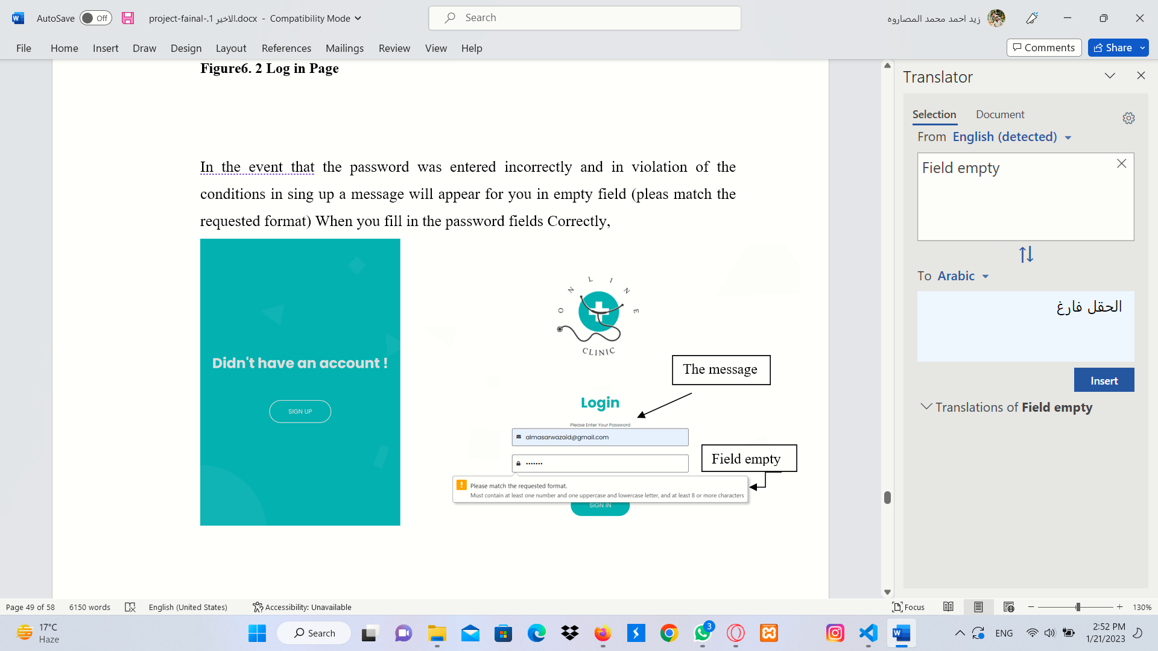

Figure6. 3 Log in Page

### Create Account

When you click on (create) button, and the fields are empty it will show the message (please enter your information)

Figure6. 4 Create Account Page

In the event that the password violates any conditions in format; the conditions are (lowercase latter, capital latter, number, minimum eight character)

Figure6. 5 Create Account Page

If you leave one of the fields empty, it will show you the message in empty fields please fill out this fields)

Figure6. 6 Create Account Page

### Make Appointment

If you leave any empty field on the Appointment Reservation page, the same message will appear (please fill out this field).

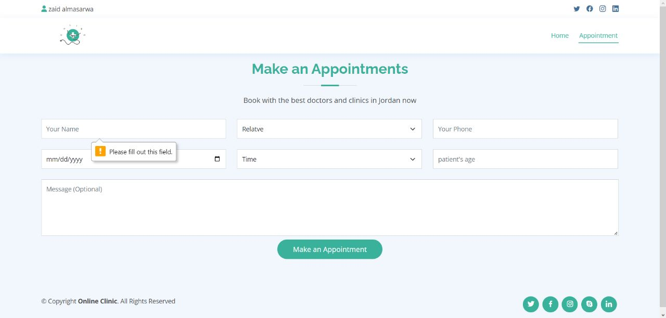

Figure6. 7 Make Appointment Page

## Expected Error

1- When writing the URL of the logged-on account in the location bar without logging on the user account, it shall show the log-in page, not the account.

2-Each account has id number, and each appointment has a different id number as well.

3- Any earlier appointment or any booked appointment with any doctor will be locked.

As shown in figures respectively

Figure6. 8 Expected Error

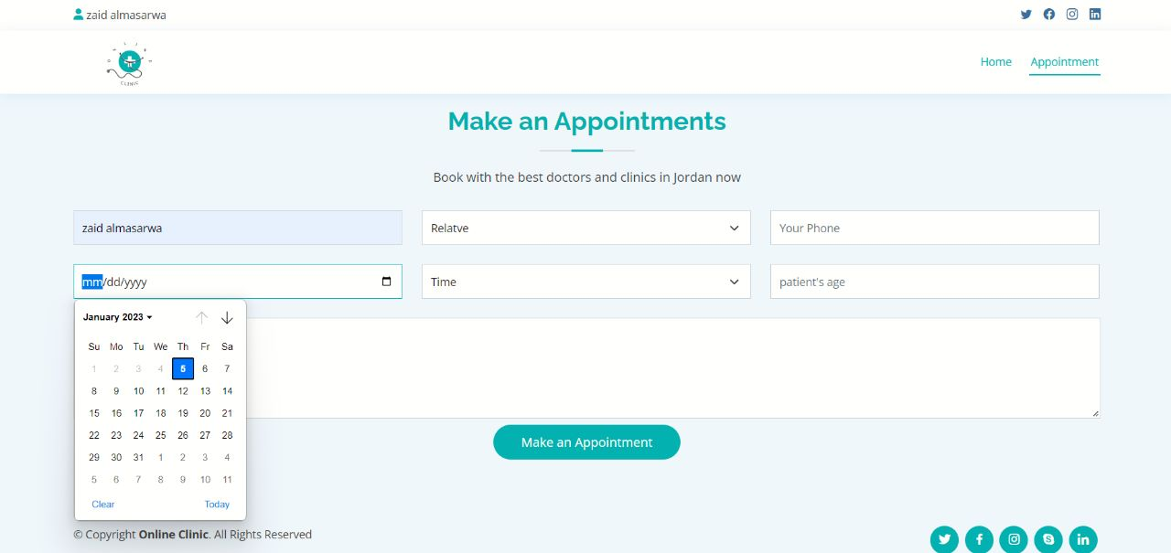

Figure6. 9 Expected Error

4- An appointment button on the home page is disabled and when user log on his account the appointment button on the home page will be enabled

## Survey the result.

Online clinic is tested by doctors, and we collected some opinions about it. The doctor told us that Online Clinic is a good electronic system to arrange electronic appointment is better than booking manual appointments Also, Online Clinic consume less time, effort, and cost. Doctor said Online Clinic don’t need papers and employees to arrange appointments, only Online Clinic system is enough. The patients told us that the Online Clinic is successful Also. They don’t need to wait for a response to the calls in the clinic. The information was clear and easy to understand. Patients said they don’t need anyone for help. Online Clinic is good and easy to use. It is compatible and not complicated. The design of the site is beautiful, not complicated, or difficult to use.

We believe that Online Clinic is successful, and the comments were good from both doctors and patients.

# CONCLUSION

## Conclusion

Technology has become an integral part of our lives, especially for Senior medical and economic role, providing an inspiring field to work in and create projects that are usually successful by meeting the needs of individuals and companies at this time.

With our studies and the real life, we realized that we cannot live without IT services; Therefore, we chose Online Clinic to develop A convenient site for doctors and patients, linking the clinics' services to their beneficiaries.

In this project, the incremental development methodology was used in an agile environment, which helped us to add suggested changes to the project. without encountering problems. As a result, we delivered the project on time and with desired result.

The project was completed by making accounts for doctors and a patent, and offering services to him, such as Appointment booking, location etc.

Our project has achieved its intended goal perfectly, so we can say that we have made a perfect successful project.

## Limitations

We have presented our best skills and knowledge in the development of this site, but any project contains restrictions and challenges as obstacles in front of us:

Hence the most important challenges are:

1- The lack of time that generated work pressure during the completion of such a project.

2-One of the team members left the group, so we had to cover his work and that put extras pressure on us

3-Envouerment issues (The protest that occurred agents increasing of fuel price, so we unable to reach to the university, and the problems associated with it, such as

internet disconnection (difficult communicating with the doctor and with the team).

## Future Works

The development of any system is very essential to keep up with the developments around.

Improving system performance and to be better than competitors in the future. We are always keen to keep abreast of changes in the system to make it keep up with everything.

There are some different ideas and suggestions to improve the site in the future:

1. Providing private chat rooms between the patient and the doctor that guarantee privacy.
2. Create a realistic company building for our website.
3. Our website has become an application that also works on Android devices and iOS.
4. Availability of a call center to receive calls from all users at any time to provide solutions. for suggestions and problems, they face.
5. Using artificial intelligence (AI) within the system to improve system responsiveness and to provide high quality services.
6. Contracting with an official body to receive the largest number of doctors from various specialties and from all regions.
7. Verifying the emails for more security.
8. Providing Social media icons in Online Clinic for both the patient and the doctors.

references

[1] [Bloomsbury university -- University of Minnesota human rights office]

[2] Gout, L.(2017,February10).BookingClinic.https://www.bookingclinic.com/en \[accessed 1.11.2022]

[3] Richardson, M. (2017, February 10). Skip the Waiting Room. <https://skipthewaitingroom.com> [accessed 3.11.2022]

[4] (n.d.). Doctor Online. [https://tabebyonline.com/ar/clinic?fbclid=IwAR0N6ylWOAe7IWc0C9Q5msuHeclRr581xMr2H0SNqBHD3w8P-xgMBKLwLg8](https://tabebyonline.com/ar/clinic?fbclid=IwAR0N6ylWOAe7IWc0C9Q5msuHeclRr581xMr2H0SNqBHD3w8P-xgMBKLwLg8%20%20%20%20%20%20%20%20%20%20%20%20%20%20%20%20%20%20%20%20%20%20%20%20%20%20%20%20%20%20%20%20%20%20%20%20) [accessed5.11.2022]

[5] Al-Labadi, A. (2008). Altibbi. https://altibbi.com/اسئلة-طبية/اسأل-الطبي [accessed 6.11.2022]

[6] (2014)TEBCAN.https://tebcan.com/ar/Jordan?gclid=Cj0KCQiAt66eBhCnARIsAKf3ZNEoUmLYJnAV3qt4S1QrWi1Lh6j-6CX5ycuL_X8SWIQgpbXk7uHWufMaAt52EALw_wcB[accessed 8.11.2022]

[7] https://www.javatpoint.com/software-engineering-incremental-model [accessed 9.11.202]

[8] Sourabh Arya, Requirement Determination Process, Bangalore, Bangalore, India, Dec. 23, 2009

[9]] Davey, L. (2021, October 12). How to thoroughly document your project requirements: https://www.teamwork.com/blog/project-requirements [accessed 11.11.2022]

[10] Ian Sommerville (2009), SOFTWARE ENGINEERING, Ninth Edition, Addison-Wesley, USA

[11] Functional vs. Non-functional requirements. (n.d.). Jama Software. <https://www.jamasoftware.com/requirements-management-guide/writingrequirements/functional-vs-non-functional-requirements> [accessed 15.11.2022]

[12] Related: 111 Types of Testing in Software https://www.indeed.com/career-advice/career-development/types-of-testing [accessed 17.11.2022]

[13] 16 Jobs in Cybersecurity To Consider Today <https://www.indeed.com/career-advice/finding-a-job/jobs-cyber-security> [accessed 20.11.2022 ]

[14] Gregor, Shirley; Jones, David ,THE ANATOMY OF A DESIGN THEORY, ANU Research Publications, Journal article,2007 March 22

[15] Ian Sommerville, SOFTWARE ENGINEERING, Ninth Edition, Addison-Wesley, 125, October 2009.

[16] -Silberschatz, Korth and Sudharshan Data base System Concepts, 6th Edition, McGrawHill,2010.

[17]-https://www.educative.io/edpresso/what-is-a-database-schema [accessed 1.12.2022]

[18] jQuery AJAX Introduction. (n.d.). W3schools. Retrieved May 8, 2022, from https://www.w3schools.com/jquery/jquery_ajax_intro.asp[accessed 3.12.2022]

[19]-https://www.php.net/manual/en/intro-whatis.php [accessed 5.12.2022]